- \(…)\Strip transfer\Process Values
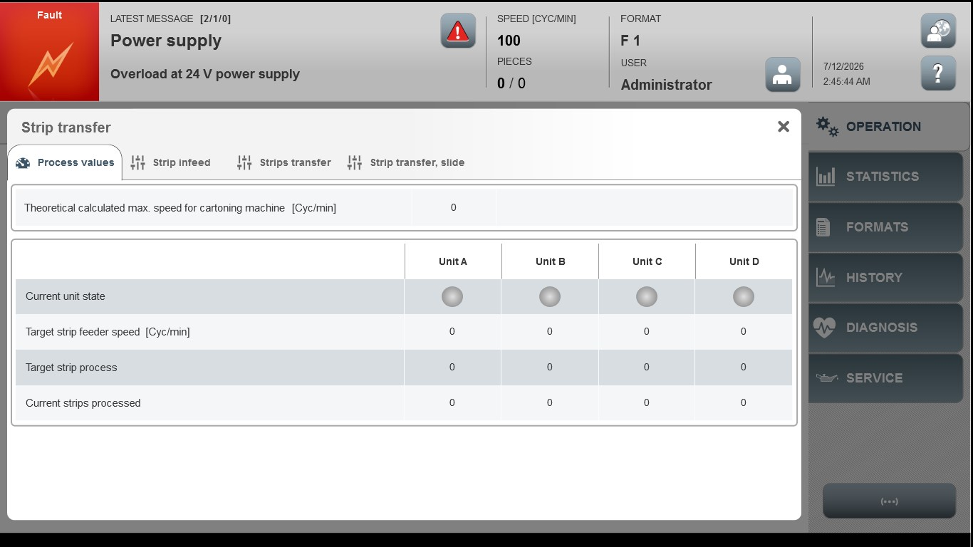
Acceptance criterion | Limits | Pass / Fail: Dev-No. | Date | Initials
Screen matches screenshot | N / A
Speed [%] | 5 … 100

